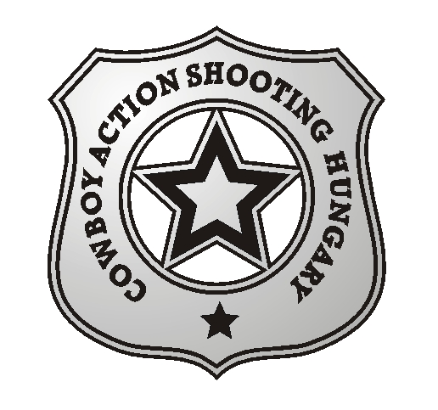

Cowboy Action Shooting Hungary announces the
“Wolfhunting”
COMPETITION OF COWBOY ACTION SHOOTING

We invite you to the “Wolfhunting” COMPETITION OF COWBOY ACTION SHOOTING held on

07.03.2015.

The event will take place on the Shooting Range Dabas Paphegy
GPS coordinates: N 47.166026, E 19.311383

Programme

Saturday:
08.30 registration
09.20 opening ceremony
09.30 shooting 4 stages
13.30 Long Range (100 m)
15.00 award ceremony

Awards: medal and certificate for the first three places according to categories

Match Director: Colorado Frank (Mikó Ferenc)
Range Master: El Heckito (Csuka László)

SASS rules apply!

Buffet and warm dishes are not available on the shooting range!

Registration fee: 4000,-HUF or 15,-EUR.

Registration is possible via email to leslie5505@gmail.com (mobile:+36209410989)

Cowboy Action Shooting Hungary

