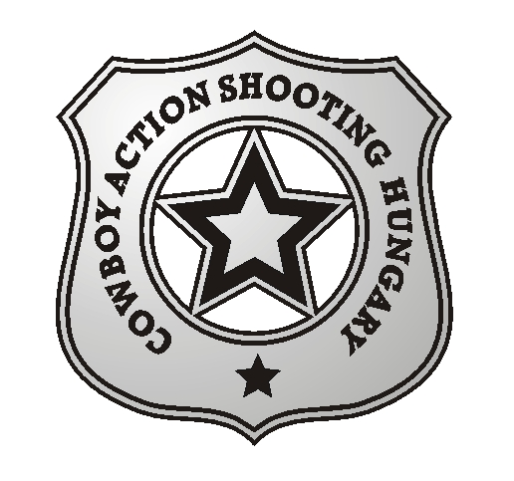

Cowboy Action Shooting Hungary announces the

10. Hungarian Open Cowboy Action Shooting National Championship

We invite you to the 10th Cowboy Action Shooting National Championship held on

August 22 2014 – August 23 2014.

The championship will take place on the Shooting Range Dabas Paphegy
GPS coordinates: N 47,166026, E 19,311383
Programme

Thursday:
13.00 - 18.00 arrival and registration on the shooting range

Friday:
08.30 registration
09.20 opening ceremony
09.30 shooting the first 6 stages
13.00 -14.00 lunch
14.00 continuing the competition
16.00 Long Range

Saturday:
09.00 shooting the remaining 6 stages
13.00-14.00 lunch
14.00 continuing the competition,
18.00-19.00 award ceremony

Awards: medal and certificate for the first three places according to categories. Cup, medal and certificate for the Hungarian National Champion.

Match Director: Horsegunner (Dombi Sándor)
Range Master: El Heckito (Csuka László)

SASS rules apply!

Every SASS categories are open to register, but we open a category for the match with at least 4 participants, applied for Men's categories, all Lady's categories will be open even with a single competitor.

Buffet and warm dishes are available on the shooting range and nearby. On Friday all contestants are invited to lunch.

Pre-registration until August 15 2014.

Pre registration fee: 10.500,- HUF or 35,-EUR
Registration fee: 12.000,-HUF or 40,-EUR.

Application, and invitation forms are available at www.cashun.hu.

Registration is possible via email to cashun.hu@gmail.com or via mobile:+36209410989

Accommodation is not provided by the organizers.
Free camping (limited) on the shooting range, no current supply, but water available!
___________________________________________________________________________

